Chapter 1-[Math Review](https://mfleck.cs.illinois.edu/building-blocks/updates-fa2017/math-review.pdf)

Monday, December 26, 2022

2:01 PM

Sets:

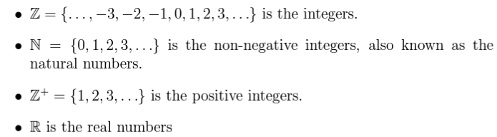

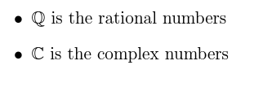

Infinity is not a number.

